Final Design Document: ShareSomeArt

Matthew Miller & Abdinasir Aidrus
Franklin University
COMP 495
Prof. Yuying Wang
11/23/2025

Final Design Document: ShareSomeArt
Software Modules
This project will have four major modules. The four are user authentication, Create Post, Search and Feed.
The user authentication module handles all aspects of authenticating and creating a user. Such as user registration, user login, and user logout functions. It is also important for the session/user to be handled and transferred between pages.
The Create Post module handles the creation of posts by the user to be shared to their followers. This will take in the user from the session, and all relevant information that comes with posts (description, title, tag, image).
The Search module communicates with the database and allows users to user search terms to find one of three options (User, Title, Tag) that they select to find posts related to the search criteria and display them to the user.
The feed section interacts with the database and pulls all posts by users that the current session user follows. The posts will be organized from most recent to oldest in the database.

Use Case Diagram
This is the typical use case between a user (poster) and the target user (follower).
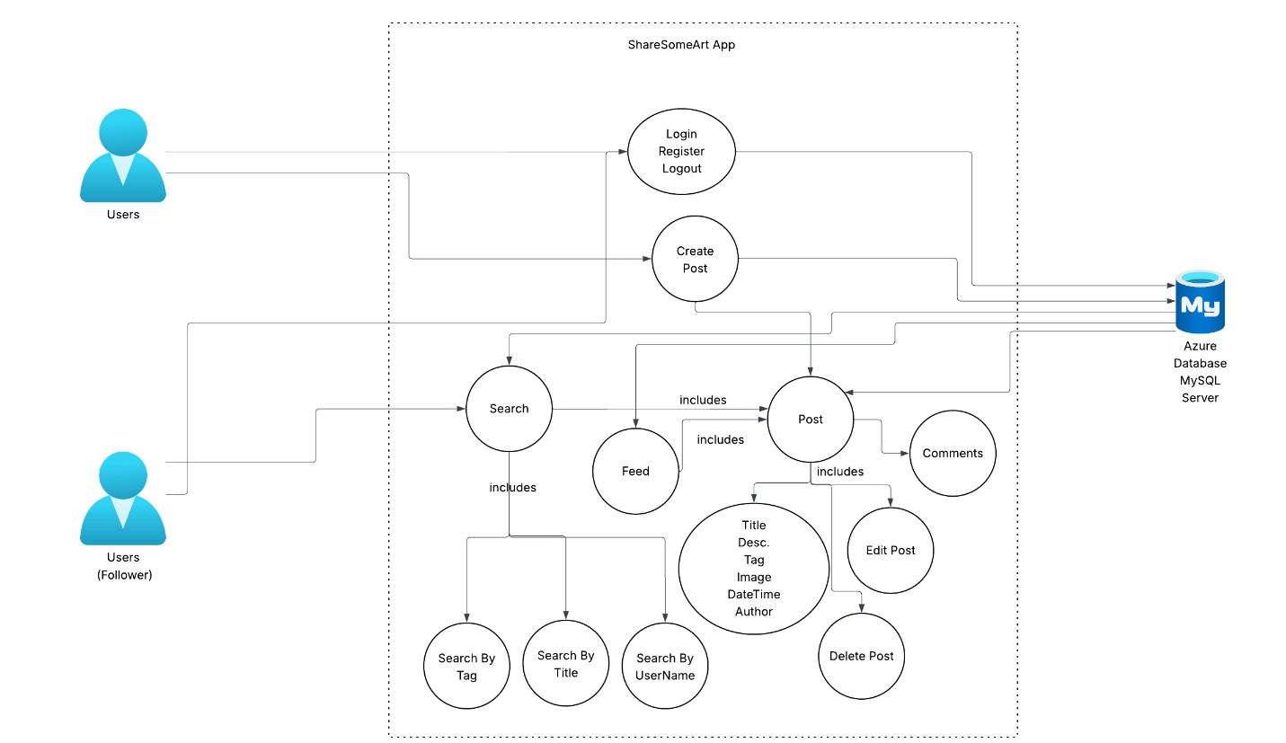

Database Architecture
We will be using a mySQL server hosted by Microsoft Azure cloud services. Schema is structured as a relational Database.
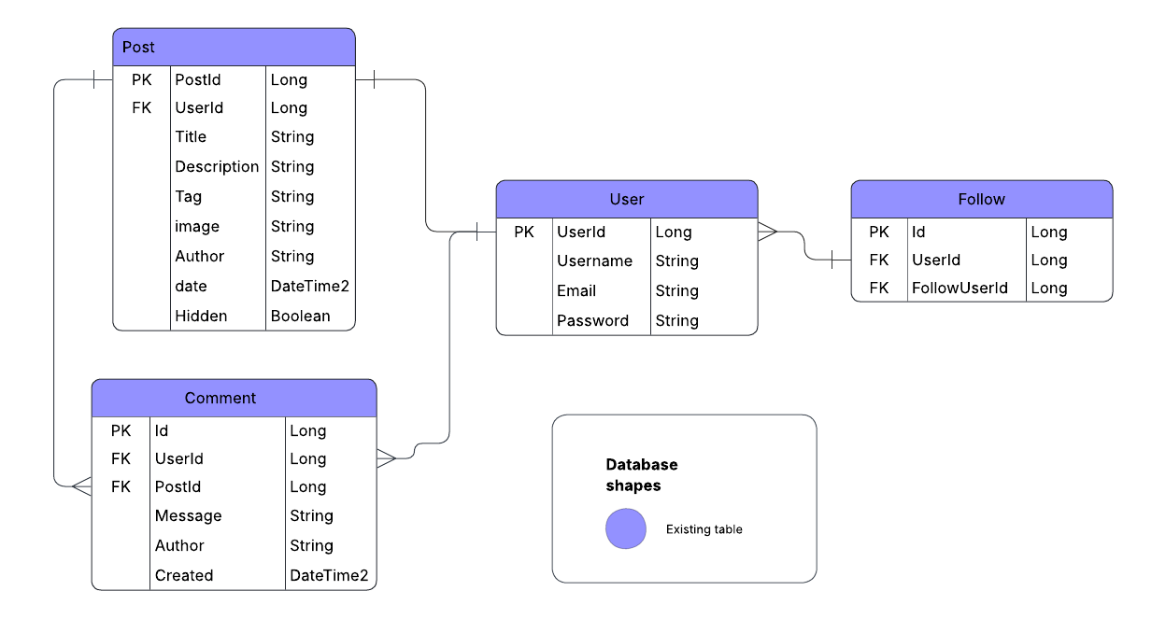
Application Architecture
The architecture for this application will follow the typical MVC (Model, View Controller) web app architecture.
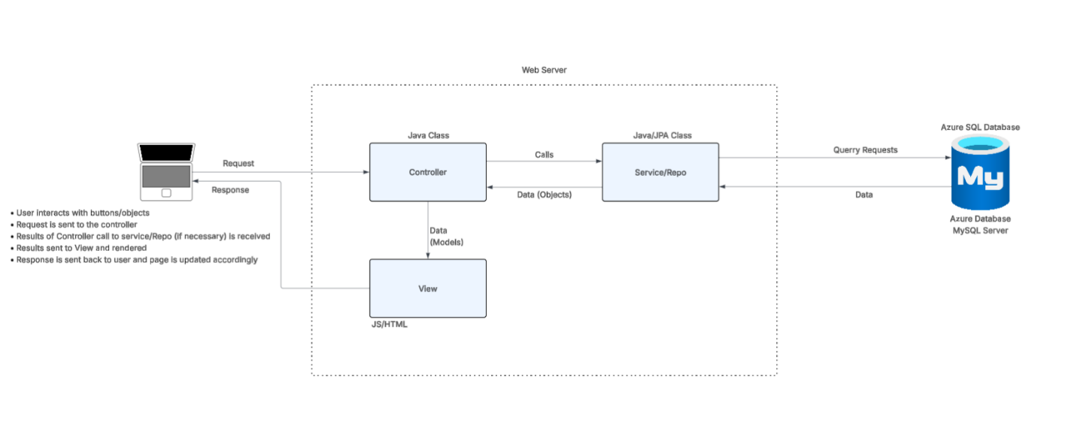
Tech Stack
This is the tech stack we will be using for this project.
- Front End: HTML, CSS, Bootstrap, JS
- Backend: Java, SpringBoot, JDBC, JPA
- DB: MySQL hosted through Microsoft Azure cloud services.

